INVESTIGATING THE TRUE VALUE OF BONDS IN THE LAST 5 YEARS
BY MUKUKA MFULA

ABSTRACT
This investigation will look at the return on investment that government bonds have shown from 2020-2025 in relation to inflation rate. The bonds used for this study are the ones that had the lowest tenor which tends to be 2-3 years varying on the issue. The main goal is to paint try and paint picture on the reality of the return on investment on government bonds. It is important to note that for this study deductions related to the returns are not taken into consideration.
Key terms:
Cut-off yield rate refers to the highest yield at which governments or central banks accepts bids in an auction of debt securities.
Inflation rate refers to the rate at which general commodities increase in value at a given time.
Sources:
https://www.boz.zm/markets-securities/bonds (Accessed: 28th March 2026).
https://tradingeconomics.com/zambia/inflation-cpi (Accessed: 28th March 2026).

Investigation
The following graph will show the trends of inflation and cut off yield rate from February 2020 to December 2025: 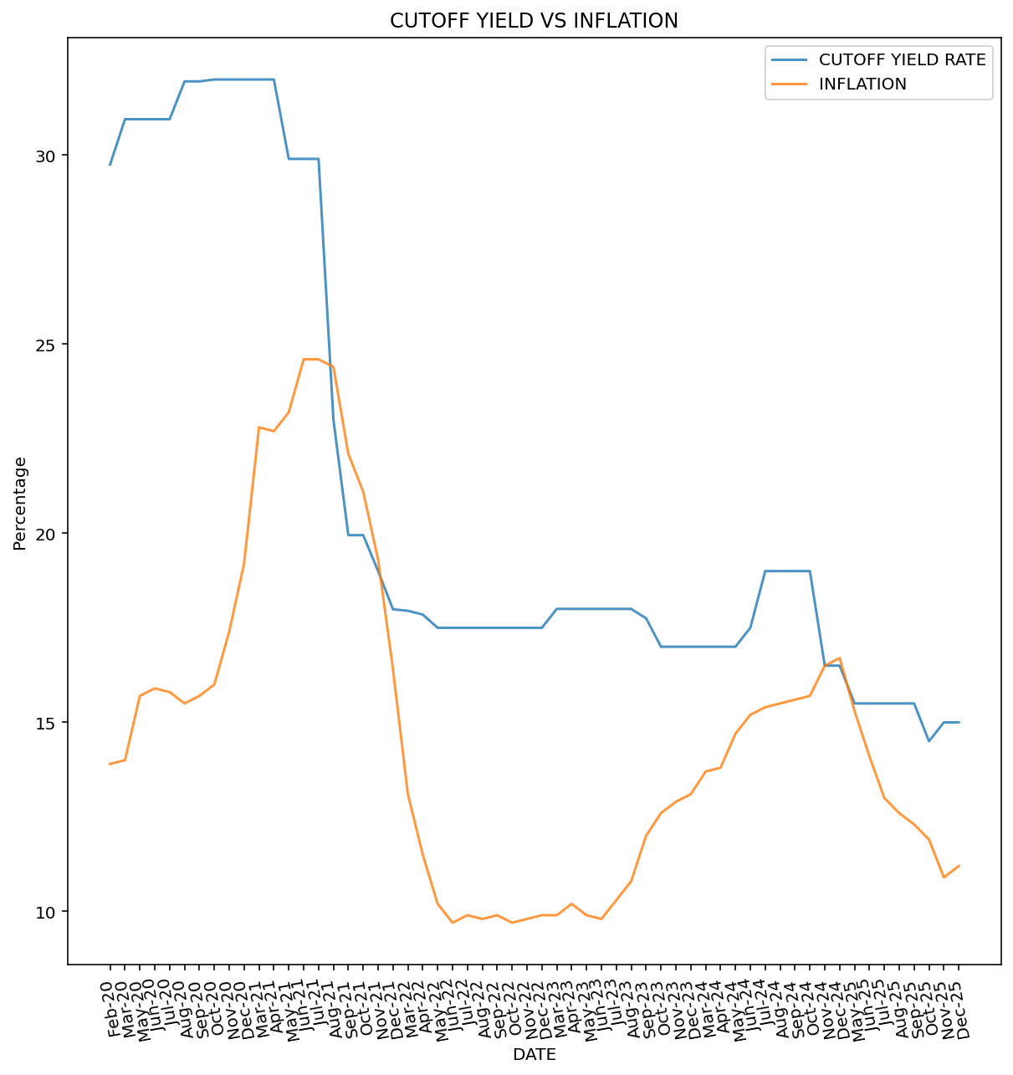

Although the cases do not happen frequently the graph shows that the have been times when inflation was higher than cut off yield. This represents a reality where the investment in government bonds wouldn’t have seen positive returns for the most part however the inflation rate. March 2020 a period when the COVID-19 pandemic first hit the country saw the largest potential returns when cut off yield was 30.95% and inflation was at 14%. In October 2025 the lowest cut off yield was observed at 14.50%. It is important that we look at what we will call true value, which is in this case is subtracting inflation from cut off yield rate.

REAL VALUE
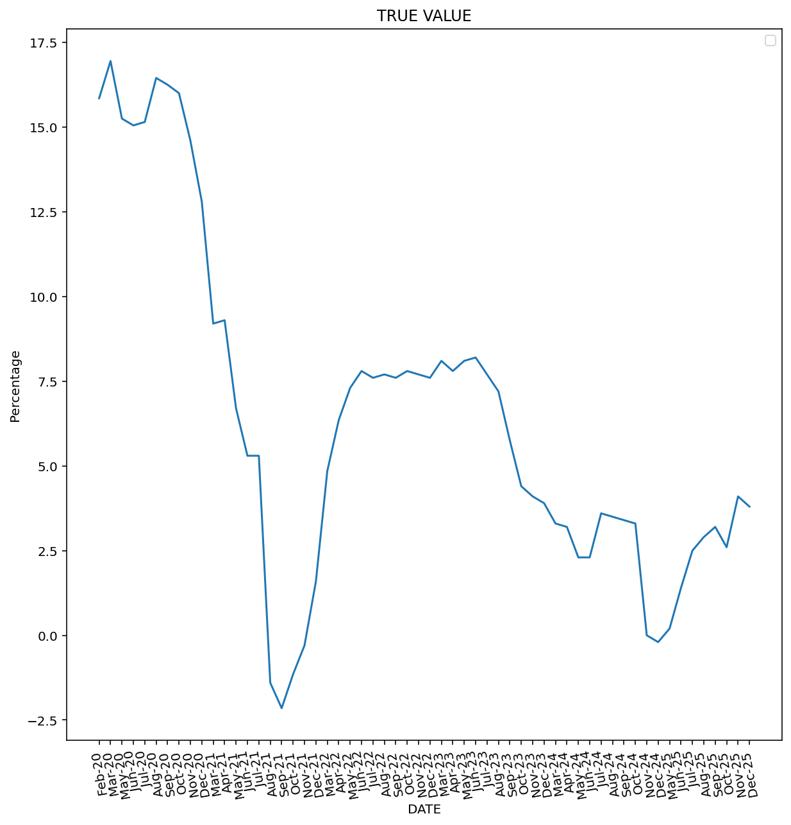
From this graph the peak of the true value was in 2020 with the highest value being recorded in March 2020 at 16.95%. The was a sharp decline in true value which so it at its lowest rate in -2.15% in September 2021.

